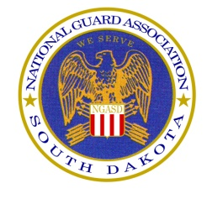

# NGASD

# Mid-Winter Meeting

### AGENDA

* Call to Order
* Pledge of Allegiance
* Adjutant General’s Comments
* Roll Call
* Approval of Previous Meeting Minutes
* Treasurer’s Report
* Warrant Officer Report
* Junior Officer Report
* Executive Director’s Report
* Corporate Membership Report
* Membership Report
* Museum Report
* Insurance Report
* Call for Nominations
* Call for Resolutions
* Report on 63rd State Conference
* Adjournment

### 1 February 2018

### 1400 CST

### South Dakota National Guard Museum

### Pierre, SD